Stree Overlord is suitable for hypertension and cardiopathy patients,please be reassurance to take this product.
Research and developed exclusively by the Japanese Mayo kaisha international biology technology company,Stree Overlord is a patent health care product specially for functionally complementing kidney and strengthening vital energy of men,which contains twelve net natural plants with the function of improving men enginery.Stree Overlord was researched and developed by scientists over ten years in company,adopting the most advanced purification technology in the world and international top production equipment.Eliminating the false and retaining the ture,made from super purification,Stree Overlord is a supplement product for men function with the double effects on improving kidney and strengthening vital energy as well as enlarging penis.Stree Overlord can help you to reestablish your male power,reappear your man quality in a short time.
Stree Overlord has been sold thousands and million after it is launched in Asia,which brought happiness to innumerable men.
- [Product Name]: Stree Overlord (Make in Japaness Mayo Kaisha Pharmacy Export Ltd.)
- [Mechanism Function of Stree Overlord]: Stree Overlord is a long effect spermary elements pills,It has a marked male hormone live nature with albumen assimilation and stimulating marrow building blood function,accelerates blood corpuscle growth and sperm building.
- [Scope of using of Stree Overlord]: Functionality sexual impotence,prostatitis caused from neurasthenic or spirituality,as well as Stree Overlord can be used in sexual impotence caused from diabetes etc.
- [Notice of Stree Overlord]: Minor is not allowed to use Stree Overlord,Stree Overlord should not be repeatedly used within 24 hours.
- [Comments of Stree Overlord]:Stree Overlord is through the absorbing of the lymph,not through the liver.Therefore,there is no affect to function.
- [Usage and Dosage of Stree Overlord]: Take one pill before sexual intercourse 20 minutes.
- [Storage Method of Stree Overlord]: Airproof,cool,dry places.
- [Manufacture Date of Stree Overlord]: Refer to package cover.
- [Specification of Stree Overlord]: 3800mg*4 pills/Package.
- [Quality Guarantee period of Stree Overlord]: 4 years
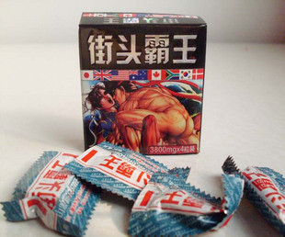
For More Info Contact at 396-0316, email: frassout@gmail.com , Blackberry Pin 22298698

